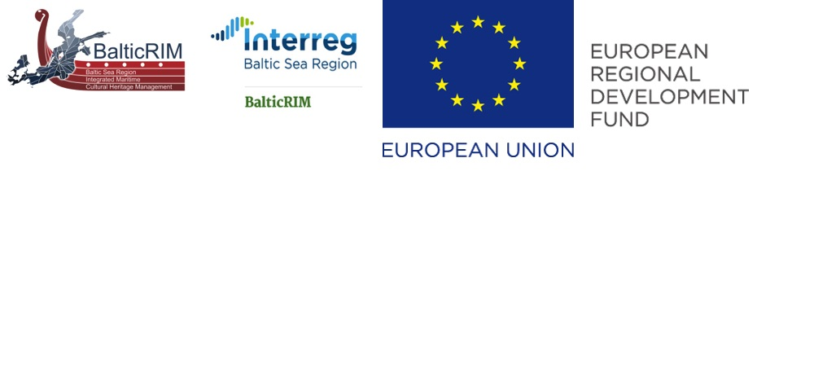
Progres report on stakeholders involvement

BalticRIM report - GoA 3.1

Magdalena Matczak, Jacek Zaucha, Jakub Turski, Joanna Witkowska,

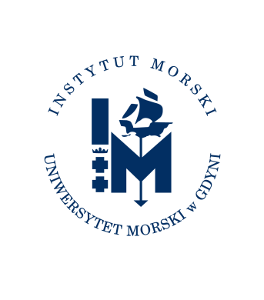

Gdańsk, October 2019

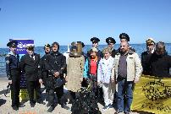
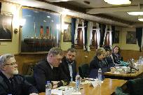
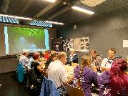
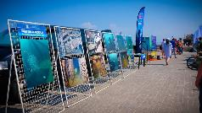
Table of content

1. Introduction 3
Stakeholder participation 3
The goal of the GoA 4
2. Performed activities 5
2.1. Description of some of the stakeholder workshops 9
2.2. BalticRIM at external events 15
3. Conclusions 17
Good examples 17
Recommendations for further stakeholders involvement 19
4. Bibliography 21

Introduction

Stakeholder participation
The involvement of stakeholder in the planning process, both in terms of the sectoral or cros-sectoral character is one of the tools to ensure access to their own data and knowledge and to enhance the transparency of the sectoral planning, including stakeholders involvement.
In Maritime Spatial Planning the dialogue with sector representative is seen as a requirement to reach the harmonisation of interests, mutual understanding and sustainable coexistence in the planning area.
The stakeholders involvement issue has been always addressed in the European projects regarding maritime spatial planning topic. A dedicated project was performed between 2012-2014, called PartiSEApate, which aim was to deepen the knowledge about requirements and mechanisms of stakeholder participation, transnational consultations and multi-level governance. Within the project the dialogue with individual sectors was established to check their need of involvement in MSP process. The research done by the project partners revealed, among others, that different sectors prefer to be consulted at different levels.
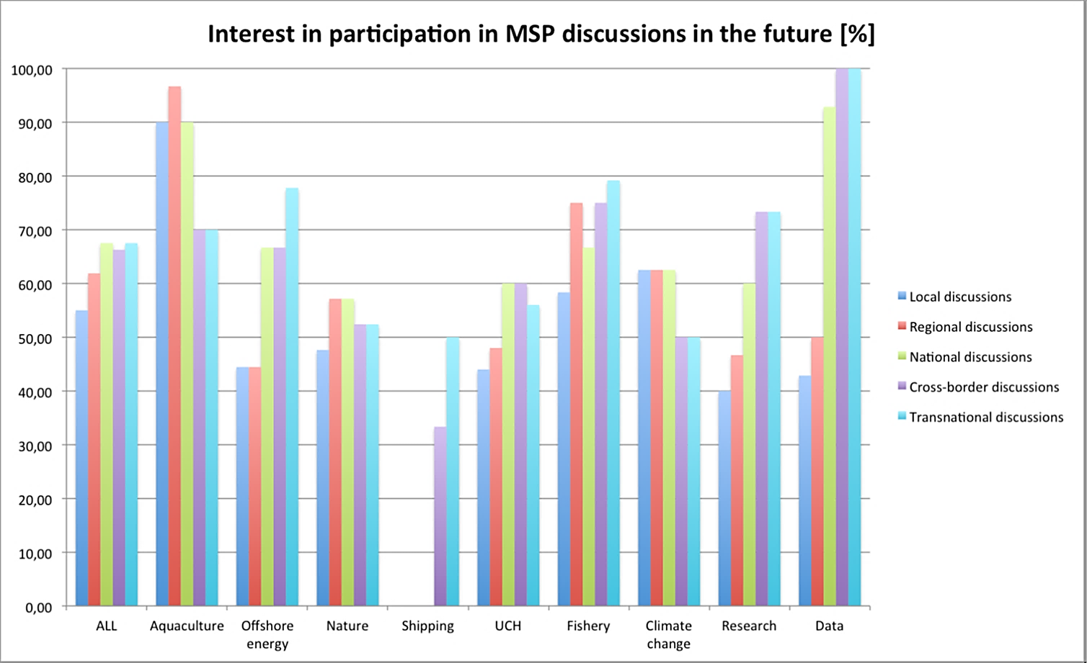

One of the project finding was that Maritime Spatial Planning is considered as a multilevel and cross-sectoral debate/dialogue platform revealing potential conflicts and synergies in relation to internationally/nationally/regionally agreed goals concerning using, sustaining and conserving marine ecosystem. Furthermore multilevel consultation premise is to ensure a sense of 'ownership' (understood as rights, obligations and interests) of the sea areas to be created and accepted by all stakeholders involved in the MSP.
Within the ParteSEApate project the requirements of the underwater cultural heritage sector was also examined. It resulted that the sector is rather well coordinated within region via the pan‐Baltic level cooperation platform – a working group established under the Council of the Baltic Sea States (CBSS) and manifest its will to be actively involved in pan‐Baltic MSP dialogue to ensure its interests.

The goal of the GoA
The sectoral workshops were considered as an excellent platform to verify BaltiRIM WP2 findings with the national stakeholders as well as to be source of additional and practical knowledge regarding maritime cultural assets within the countries. The first round of the workshops was meant to introduce the project aims, the concept of MSP, WP2 findings regarding sectoral maps and to develop more deeply the case studies concepts. Due to the difficulties experienced within the WP2 (see reports pointing the difficult, prolonged discussions on schematisation, transnational categorisation and data gathering), the workshops’ idea was reformulated and left to the decisions and requirements of the individual partners. The reason of it was that they have the best knowledge of what need to be included, what are the knowledge gaps, what kind of stakeholders involvements would be the most suitable. The approaches to the task differs between the partners, hence the report is meant to gather this two years’ experience and give guidelines for the last period of the project.

Performed activities

The PartiSEApate handbook calls the Arnstein’s ladder of public engagement to explain a variety of options:
- Information – Providing information. (E.g. about the existence of a service, results of a decision).Tends to be one way communication: from MSP organizers to stakeholders
- Education – Explaining or raising awareness of something - often in order to change attitudes/action. Tends to be one-way communication: from MSP organizers to stakeholders
- Consultation – Asking opinions of stakeholders. This can include various ways of asking for opinions or reactions to particular draft decisions. It can have a form of phone inquiries, focus groups or debates. It can be two way communication (e.g. if participants are informed of the results) however, final decisions are made by those who are doing the consulting.
- Involvement – Where more than just opinions are expected. Participants can be part of the solution development process’ by taking action, endorsing something, etc. Communication must be two way, responsibilities are not necessarily formally set out and relations between participants may remain unclear.
- Partnership – Direct involvement in decision making and action, with all parties having clear roles and responsibilities and powers – usually for a defined purpose/shared common goal. Two-way communication essential.
- Devolved Power – Delegating decision making, resources and control. Accountability should be clarified and it should involve two way communication with those giving away the power.
The table below summarise the activities reported by the partners within the GoA 3.1.
Looking at the meetings’ types there are differences of approaches, depending on the needs and goals. Hence meetings could be divided into:
(depending on the number of participants)
- Small – up to 10 persons
- Medium – 10-50 persons
- Big – over 50 persons
(depending on the goal)
- Providing Information
- Screening the resources
- Awareness rising
- Asking for feedback
- Solution finding
(depending on stakeholder group)
- Sectoral
- Cross-sectoral
- Institutional
(depending on organizers)
- Internal – organised by the project
- External – organised by other entity with project involvement.
Date | type | goal | Stakeholder group | Summary | Results
GERMANY
06.02.2018 | Cross-sectoral stakeholder workshop | - Providing Information  - Awarness rising | - Flensburg tourist board  - Flensburg maritime museum  - Langelands Museum (DK)  - PP13 (DK) | Stakeholder workshop for Flensburg Fjord to discuss the goals of the BalticRIM with regard to the Flensburg Fjord as one of the cross-border management case areas. | Data acquisition: UCH on the Danish side of Flensburg Fjord  Collecting ideas
24.11.2018 | Sectoral Stakeholder workshop  >50 | - Awarness rising  - Screening the resources | - Over 70 scuba-divers from Schleswig-Holstein | Publically advertised workshop for sport-divers to start a dialogue regarding the underwater cultural heritage. The aims of the ALSH was to increase awareness on the susceptibility of the UCH, the procedure of reporting new finds, and to explore possibilities for future cooperation and voluntary diver involvement, e.g. in management pilot cases. | Statistic data on dive sites and general interests evaluated through a questionaire  Feedback from the diver community on problems and interests
16.01.2019 | Small meeting - Institutional dialoge | - Providing Information | Maritime Spatial Planners, responsible for coastal waters (Ministry of the Interior, Kiel) | Meeting with the spatial planners of the Ministry of the Interior (Kiel), responsible for MSP in Schleswig-Holstein’s territorial waters, to present the the goals of the BalticRIM-Project | General feedback on the procedure and mode of future correspondence
20.03.2019 | Small meeting  sectoral | - Providing Information  - Practical arrangements | 2 divers | Meeting with two professional divers to gauge the interest to appoint a volunteer for monitoring a sea battle site of 1715 near Bülk, which incorporates the wrecksite of HEDVIG SOPHIA. The volunteer could become active under water in accordance to the confidants-scheme as regulated in the law. | The diver agreed, thus the ALSH’s confidants scheme will be extended for the first time to an underwater site
07.06.2019 | Small meeting - Institutional dialoge | - Providing Information  - involvement arrangements | State Agency for Historic Monuments of Schleswig-Holstein (Landesdenkmalamt) | Presentation of the BalticRIM-project. The goal of this meeting was to initiate a cooperation in order to include also built & technical heritage in the coastal zone and to make use of the ICZM tool in fulfillment of WP 3.3. | Close collaboration
14.6.2019 | Small meeting, Sectoral dialoue | - involvemnt arrangements | Diving Federation of Schleswig-Holstein (Tauchsport-Landesverband Schleswig-Holstein) | Meeting with the executive board of the Schleswig-Holstein branch (TLV-SH) of the VDST, the principal umbrella organization of sport-divers in Germany  Here we discussed the possibilities of how sport-divers could effectively contribute to the cognizance, reporting and protection of the underwater cultural heritage | Informal agreement to pursue a cooperation and to create a structure to integrate UCH concerns.
06.09.2019 | Small meeting - Institutional dialoge | - Asking for feedback  - Solution finding | Maritime Spatial Planners, responsible for coastal waters (Ministry of the Interior, Kiel) | Meeting with the spatial planners of the Ministry of the Interior (Kiel), responsible for MSP in Schleswig-Holstein’s territorial waters, to discuss possibilities to include MCH priority areas in the draft of the amendment to the next spatial plan (Landesentwicklungsplan, LEP). This was also a feedback on the first batch of priority areas submitted to the planners. | Feedback on priority areas and indicating how and to what extent MCH concerns could be taken into account in the upcoming LEP-revision
07.09.2019 | medium meeting - Institutional dialoge | - Providing Information  - Awarness rising | lower-level monument protection authorities | Presentation of the BalticRIM project at the annual meeting of the ALSH with the lower-level monument protection authorities (=municipalities) of Schleswig-Holstein, highlighting the possibilities of the project on a local level.
25.09.2019 | External event | - Providing Information  - Awarness rising | Stakeholder from museum and collections | Presentation of the potential and importance of early modern shipwrecks in a workshop on “The Archaeology of Modernity” with stakeholders from the ethnological, technical heritage and museum sectors, hosted by ALSH (PP01). This was an informal exchange of ideas on the relevance of very recent material culture as archaeological source. This is a highly topical theme, as most wrecks in Schleswig-Holstein’s waters are from the late 19th and early 20th century, especially the World Wars. | This discussion influences the designation of priority areas
16.10.2019 | Institutionsl dialogue? | - Providing Information  - Awarness rising  - Asking for feedback  - Solution finding | Federal Maritime and Hydrographic Agency, responsible for MSP in the German EEZ (Bundesamt für Seeschifffahrt und Hydrografie BSH, Hmaburg)  The meetings was attended also by representatives of other German state archaeology authorities with access to the sea, as well as scholars from research departments | First meeting with spatial planners of the BSH to discuss the potential of the UCH, ist threat through natural and anthropogenic factors, and highlighting the importance to include it also in the MSP of the German EEZ (despite the absence of a statutory mandate) | Although the BSH is not legally obliged, it is interested to get an informal recommendation which UCH-relevant areas to integrate in the EEZ’s MSP
FINLAND
7.04.2018 | medium  Sectoral Stakeholder workshop | - Providing Information  - Awarness rising  - Screening the resources | local and regional divers, museum officials and FHA’s maritime archeologists. I cooperation with Finnish diver Federation; | Five presentations on UCH and underwater landscape concept were presented and discused. The participants shared information on the local and regional underwater cultural heritage and the sites were mapped to a BalticRIM ArcGIS maplayer | new wreck sites were added as well as areas of underwater landscape and technical (shipbuilding) infrastructure.
5.09.2018 | medium  Sectoral Stakeholder workshop | - Providing Information  - Awarness rising  - Screening the resources | a large audience of local and regional divers from various Diving Clubs, as well as museum professionals, boaters and history enthusiasts and biologists from Metsähallitus, all together 23 participants. |  | Several new wreck sites were added to the FHA’s database. The workshop was organised the same week as the fieldwork on a pilot area in the Gulf of Bothnia and the results of the workshop fed directly onto that fieldwork.
RUSSIA
5.05.2018 | External  (Kaliningrad) | - Providing Information  - Awarness rising | dive community of the region - clubs, diving schools, other diver specialists and the individual amateur divers | AB IO RAS experts presented the project aims, geography, Blue Growth idea | The divers expressed the need to publish a brochure on underwater heritage.
2.06.2018 | Public event  (Kaliningrad) | - Providing Information  - Awarness rising | Open public | Local dive community with the resort municipality, support the event by introducing the public to underwater hunting, diving, sailing. The Museum has presented an exhibition of underwater photographs of sunken objects and information about BalticRim Project scope and aims and ideas of Blue Economy and conservation of natural and historical value of the Baltic Sea
21.07.2018 | Public event - International Women's Diving Day promotion  (Kaliningrad) | - Providing Information  - Awarness rising | Open public, mainly divers, tourists | Several diving clubs joined forces to hold the International Women's Diving Day promotion. In the framework of BalticRim project, an exhibition of underwater photo of sank vessels which are included in the tourist diving infrastructure in the Black Sea, was presented as an examples of the implementation of the Blue Growth approach in the Baltic Sea. ABIORAS experts introduced the public (tourists, divers, orphan kids, women) BalticRim Project, responsible diving and Blue Growth ideas.
9.09.2018 | Sectoral workshop  The Water Assembley – maritime fest  (Kaliningrad) | - Providing Information  - Awarness rising | Divers and diving clubs | The Museum held a huge maritime fest, the Water Assembly, dedicated to the preservation of maritime traditions. A joint program with three dive school was organized to educate about the features of diving and the conservation of underwater heritage, free test dive in the aquarium was available for public. Round table with diving clubs was held for joining efforts in the framework of the BalticRim project.
19.10.2018 | Sectoral dialogue  (Kaliningrad) | - Providing Information  - Awarness rising |  | The conference “Diving in Russia” was organized in the Museum of the World Ocean. 10 talks about UCH were presented. Use and preservation of the UCH and MCH was discussed.
21.12.2018 | Sectoral dialogue  (Kaliningrad) | - Solution finding | Researchers, | Club of the underwater researchers. The main topic was how to investigate the UCH and prevent the damage of the UCH.
1.03.2019 | Cross-sectoral workshop  (St. Peters-burg) | - Providing Information  - Awareness rising  - Asking for feedback  - Solution finding | Regional stakeholders and authorities | A Round Table «Baltic Sea Region Integrated Maritime Cultural Heritage Management»
24.03.2019 | Sectoral meeting | - involvemnt arrangements | underwater researchers | Joined plans on the summer season were discussed. Areas of investigation and methods. Preparing the agenda for the future Russian Day of Divers.
5.05.2019 | Sectoral meeting | - involvemnt arrangements | Divers, underwater researchers | Celebration of the Russian Day of Divers. The director of the Museum of the World Ocean Svetlana Sivkova has discussed with divers the joined plans of the UCH investigations.
2.08.2019 | Cross-sectoral workshop  (St. Peters-burg) | - Providing Information  - Awareness rising  - Asking for feedback  Solution finding | 25 participants | Workshop “Underwater cultural heritage in the integrated marine management plans”
16-17.08.2019 | Cross-sectoral workshop  (St. Peters-burg) | - Providing Information  - Awareness rising  - Asking for feedback  Solution finding | 30 participants | The Interagency meeting of the Russian Maritime Board on cultural heritage

Description of some of the stakeholder workshops
FINLAND
In Finland, the Finnish Heritage Agency (FHA) organised two stakeholder workshops in co-operation with Metsähallitus Parks & Wildlife in 2018. The workshops were planned to the same areas, where also BalticRIM maritime archaeological fieldwork was targeted in the same year.
In Finland, the coastal regional councils are responsible for the MSP in three different areas: The Gulf of Finland, The Archipelago Sea and the southern Bothnian Sea and finally, the Gulf of Bothnia and Kvarken area. In 2018, the FHA and Metsähallitus planned to organise maritime archaeological fieldwork in the planning areas of Gulf of Finland and Gulf of Bothnia, in preparation of the selection of special pilot areas for the project.
The workshops were aimed at local and regional diver community and were organised together with the Finnish Diver’s Federation, which is an associated partner of BalticRIM.
GULF OF FINLAND - JUSSARÖ
The first workshop was organised in the town of Tammisaari in the Gulf of Finland, western Uusimaa region. The workshop was in 7th April 2018 and included five presentations on UCH and underwater landscape concept. These were discussed with the audience, consisting of local and regional divers, museum officials and FHA’s maritime archaeologists, all together 12 participants.
The participants shared information on the local and regional underwater cultural heritage and the sites were mapped to a BalticRIM ArcGIS maplayer (see map 1).
The results were promising, new wreck sites were added as well as areas of beautiful underwater landscape with nature values. An especially valuable finding was a brickworks site situated in a location where a the River Trollshovda flows into the sea, with adjacent embankments in the river, a barge shipbuilding site and wreck sites. This information has also been used by the FHA in co-operation with regional planning, and it has been included in the FHA statements on the cultural values in the area as a site, which should be investigated before any acts in the area.
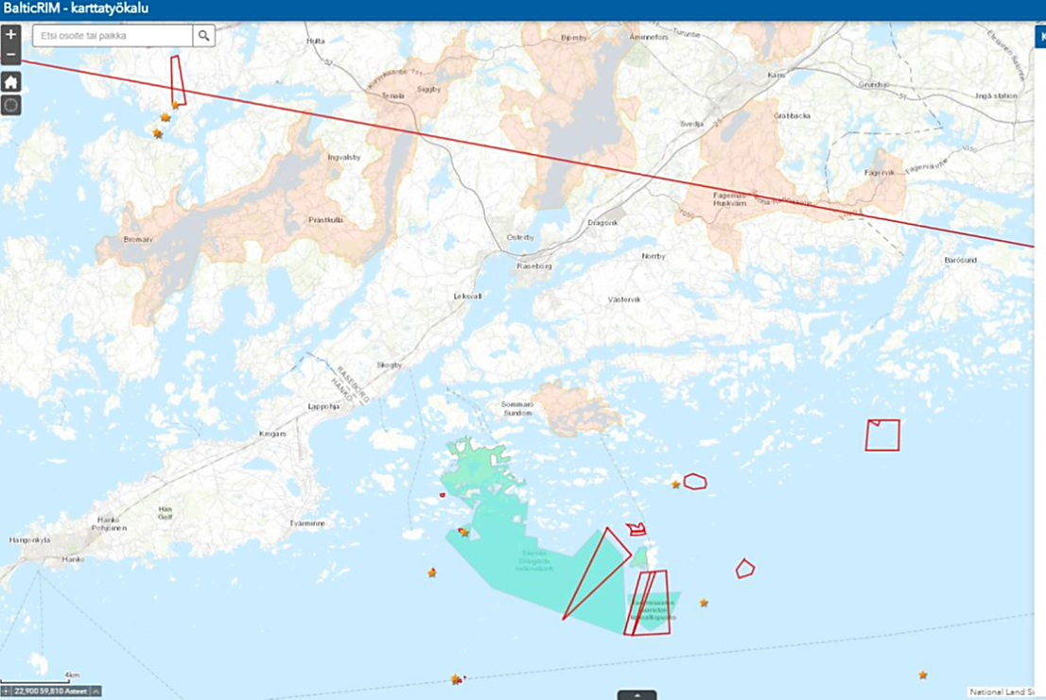
Map 1.: Gulf of Finland. Red lines mark the areas indicated by the workshop as areas of MCH interest. The stars mark separate archaeological or nature sites
Source: FHA
The participants found that especially the underwater nature values should be highlighted in the Jussarö area, where our workshop was concentrated. The sea area is a part of the archipelago national park, which is an important nature protection area and also partly under Natura 2000. This makes diving in the area a seasonal practice, as in spring and early summer, it is forbidden to land on the islands in the area because of birds nesting.
The area of Jussarö Gaddarna was chosen as a BalticRIM pilot area as it includes many wreck sites and is designated as a ship trap site. The island of Jussarö is today a recreational centre with services for campers and hikers as well as divers. A part of the island is listed as nationally significant built landscape, as it includes an iron mine that was in use from the very early 19th century till the 20th C.
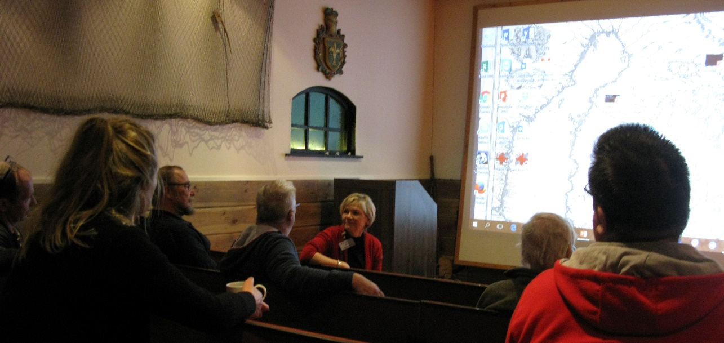
Photo: ©FHA

GULF OF BOTHNIA - LAHIA
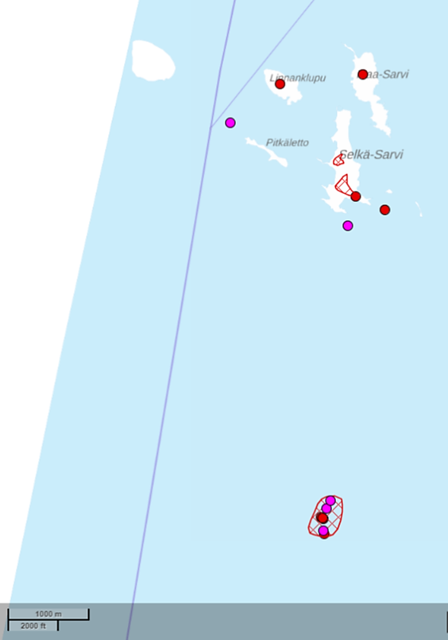
The second workshop was organised in the Gulf of Bothnia, in the regional museum of the town of Tornio on 5th September 2018. The occasion gathered a large audience of local and regional divers from various Diving Clubs, as well as museum professionals, boaters and history enthusiasts and biologists from Metsähallitus, all together 23 participants.
As a result of a lively workshop, several new wreck sites were added to the FHA’s database. The workshop was organised the same week as the fieldwork on a pilot area in the Gulf of Bothnia and the results of the workshop fed directly onto that fieldwork. We inspected approximately 6 new wreck sites and a dozen sites on land, related to fishing tradition in the region.
The Lahia shallows were chosen as a BalticRIM pilot area during the fieldwork (Map 2). The sea area contains several shipwreck sites, and is designated a ship trap. The environmental and cultural reasons behind the ship trap vary from that of the Jussarö site, which makes this an interesting comparison.
Map.2. The Gulf of Bothnia, shallows marked as red circle with the purple and red dots as UCH and MCH sites
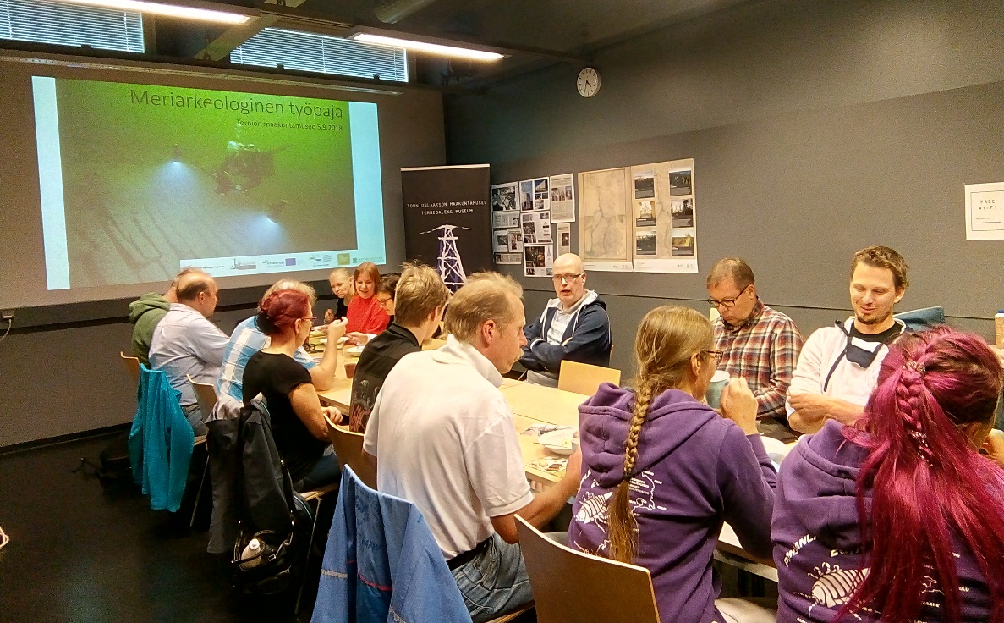
Photo: ©FHA
GERMANY
A workshop for the Flensburg Fjord stakeholders was held on 06.02.2018, as a part of the BalticRIM’s Danish-German pilot case. The cross-border meeting gathered the MSP and MCH experts and the representatives of the tourism and museum sector from Flensburg (Flensburg tourist board, Flensburg maritime museum and Langelands Museum in Denmark). The main goal was to discuss the goals of the project with regard to the Flensburg Fjord as one of the cross-border management case areas. The workshop had a constructive nature as it facilitated the data exchange on underwater archaeological sites, as well as an exchange of how the maritime cultural heritage (MCH) could serve a wider public benefit. The main focus was directed towards making the MCH more accessible through diver-trails or by an emphasis on the intangible cultural heritage.
photo: ©Wolfgang Zwick

On 24.11.18, ALSH organized a stakeholder workshop entitled “Sporttaucher und Unterwasserkulturerbe” (sport-divers and under water cultural heritage) which was attended by about 70 divers from Schleswig-Holstein and other federal states. The event, aiming at involving regional stakeholders, had two principal goals: to raise awareness amongst divers for the underwater cultural heritage, its susceptibility and protection, and also to gain information of new sites. This dual approach is crucial, as underwater archaeological surveys are carried out by the ALSH only within the framework of environmental impact assessments and rescue operations. Therefore, observations made by sport-divers are of preeminent importance to obtain data that is also relevant for the determination of the BalticRIM priority areas. The registration process was also combined with a questionnaire to gather information relevant for the management of the underwater cultural heritage and the involvement of divers. The workshop had a long-term impact, as it facilitated new contacts and contributed already to the recognisance of new sites of potential archaeological importance. observations made by sport-divers are of preeminent importance to obtain data that is also relevant for the determination of the BalticRIM priority areas. The workshop was concluded by a discussion, which raised some important questions regarding obstacles and opportunities for cooperation with sport-divers in relation to UCH in the future.
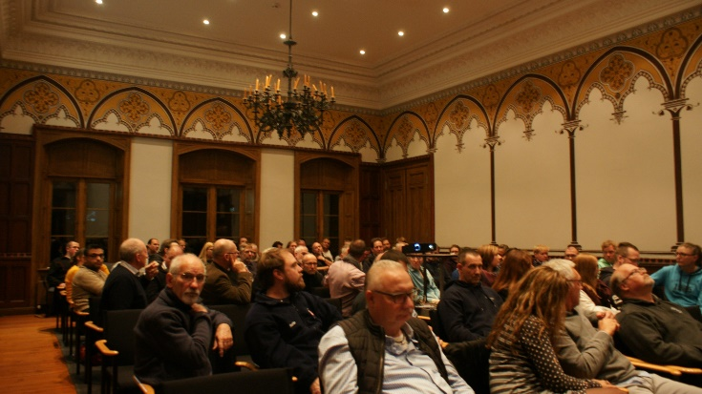 | 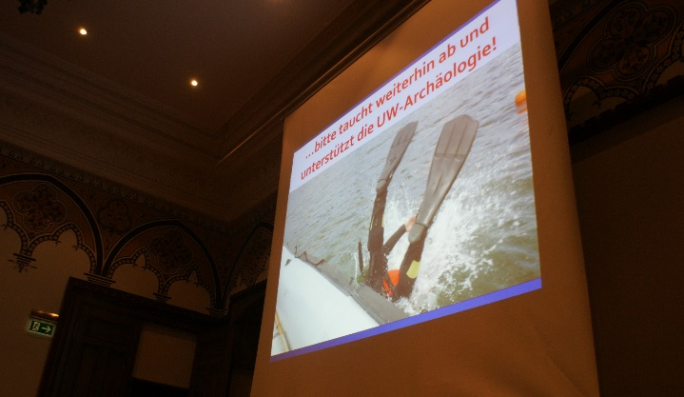
Photo: ©ALSH

RUSSIA
On the 5th of May2018, during the Russian Day of Divers, the first sectoral stakeholders meeting was organized by ABIORAS at the Maritime Exhibition Center of the Museum of the World Ocean. Representatives (26) of dive community from the region - clubs, diving schools, other diver specialists and the individual amateur divers, were invited. ABIORAS experts presented the project aims, geography, Blue Growth idea. Whereas, divers expressed the need to publish a brochure on underwater heritage.
There were 3 cross-secoral workshops prepared in St. Petersburg. Participants had been chosen by well-prepared stakeholder analyses (see subchapter 2.3).
- the Round Table «Baltic Sea Region Integrated Maritime Cultural Heritage Management», held on 1st of March 2019 in the Icebreaker Museum Krasin (the Museum of the World Ocean);
- the Workshop “Underwater cultural heritage in the integrated marine management plans”, held on 2nd of August 2019, in the Headquarters of the Russian Geographical Society;
- the Interagency meeting of the Russian Maritime Board on cultural heritage, held on 16-17th of August 2019, in the Icebreaker Museum Krasin (the Museum of the World Ocean).
The overall goal of the meetings was to inform key stakeholders about the BalticRIM project activities and to involve experts in discussion and also to contribute to the topic. During the workshops the BalticRIM project assumptions and tasks were presented. Experts have discussed the key issues of protection and use of the MCH of the Gulf of Finland. Participants have been informed about the approach to include MCH in the MSP and generally agreed with the thesis that it is necessary to limit economic activity in the places of deployment of the most valuable MCH.
Meetings attracted a strong attention to the existing gaps in the Russian legislation and to the need for a more careful scientific approach to the management of MCH. Much attention was paid to new legislative initiatives, as well as to the tourism potential of MCH in the sea and on the coast.
There were some common findings of the meetings:
- Search, identification and inspection of MCH objects is carried out by both professional and amateur organizations, and this happens uncontrollably in fact.
- Registration and systematization of identified UCH objects at the state level are not carried out due to the lack of authorized bodies.
- The data collected regarding UCH objects is usually the property of the organizations that discovered them. They do not have obligations to provide the data and may do it or not at their discretion.
- Russia has not signed the Convention for the Protection of the Underwater Cultural Heritage and has no international obligations to maintain UCH.
In result, the project resources has been data on recently identified objects of the MCH, including World Heritage sites of the WW II, have been added:
- interaction with a number of key experts - data providers established;
- experts, the public and government representatives familiar with the tool of Maritime Spatial Planning.
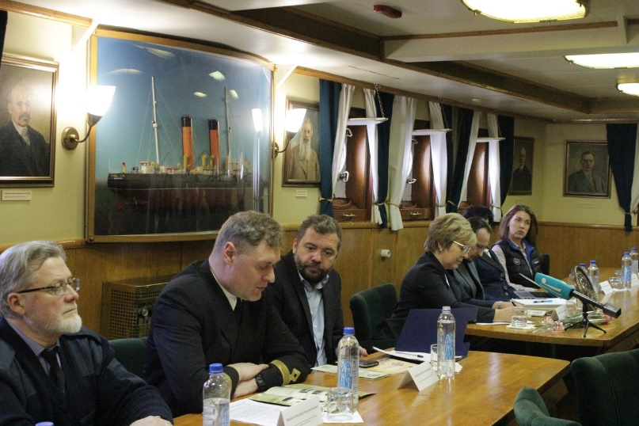 | 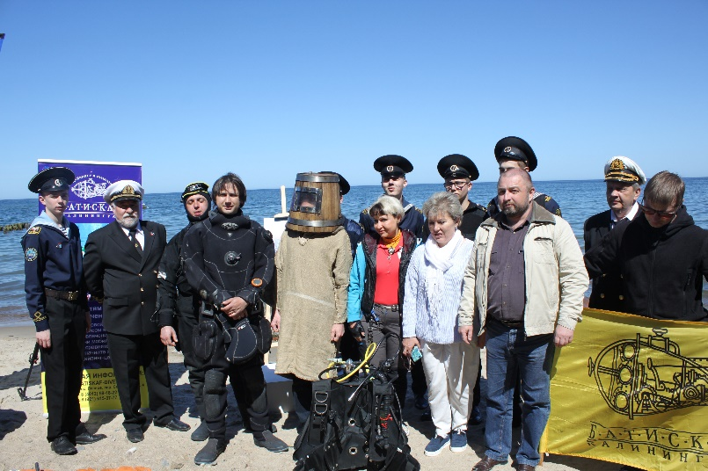
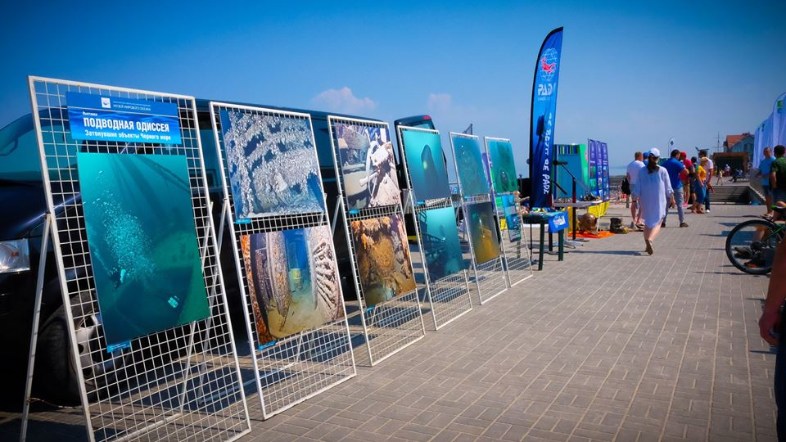  Photo: ©ABIORAS | 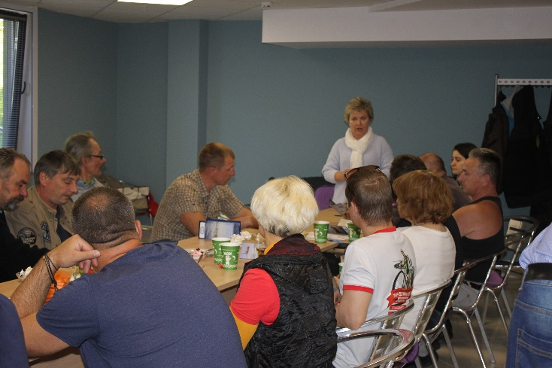

BalticRIM at external events
Although it was not a goal of GoA 3.1 it is worth to mention some of the external conferences were BalticRIM was presented and discussed with wider stakeholders audience. These were among others:
Baltic Sea States Forum in Gdańsk, Poland
On 28-30 November, several members of the BalticRIM Project attended the Baltic Sea States Forum under the heading "Cultural Heritage in Promotion and Development of the Baltic Sea Region” at the National Maritime Museum in Gdańsk, Poland. There have been made contributions by BalticRIM members to the session of the transboundary projects on the third conference day – Friday November 30th – by Sallamaria Tikkanen (Finnish Heritage Agency) as the chairwoman of the Underwater Cultural Heritage Group of the Baltic Sea Region, on the topic of the Baltic cooperation in working group of underwater cultural heritage. Iwona Pomian (Polish National Maritime Museum) presented a paper on the subject of the Underwater wreck storage in the Gulf of Gdańsk, including protection and promotion of underwater cultural heritage. Matthias Maluck (State Archaeology Department of Schleswig-Holstein) put the BalticRIM project into the context of spatial planning and other initiatives in his paper on the Cultural Heritage in Spatial Planning with examples from the BalticRIM and Lancewad Plan-Projects. And finally Julia Manukyan (Museum of the World Ocean, Kaliningrad) presented a paper on the problems of preserving the underwater cultural heritage in the Russian Federation.
MUSES workshop in Venice
On 27th June 2018, the BalticRIM project partners Iwona Pomian from National Maritime Museum in Gdańsk, Sallamaria Tikkanen from the Finnish Heritage Agency and Daniel Zwick from State Archaeology Department of Schleswig-Holstein attended the workshop organized by another important project in the field of maritime spatial planning - MUSES-- Multi-Use in European Seas. The goal of the meeting was to discuss opportunities for potential synergies between different stakeholders. Due to the presence of esperts from the BalticRIM-project, the high importance was given to the aspect of how the underwater cultural heritage could be integrated and valorized for tourism-driven planning. Participants highlighted the aggregated value of the underwater cultural heritage for other stakeholders: Shipwrecks often form natural reefs and provide the only habitats for aquatic life and a rich biodiversity in otherwise featureless underwater landscapes, to the benefit of both conservationists and recreational divers. The decline of commercial fishing due to overfishing and catch-quotas could be partially absorbed by a growing demand for dive-boats or pescatourism.
PanBalticScope Planners Forum in Helsinki
During the PanBalticScope Planning Forum on 27th September 2019 in Helsinki, the draft report of BalticRIM WP 2 - The Baltic Maritime Heritage – spatial atlas was presented. The Planning is a core group within PanBalticScope gathering the maritime spatial planners from all the Baltic countries with the aim to conduct cross-border, bilateral dialogues on specific planning problems. The draft report was warmly welcomed and a short discussion was held on the countries’ problems with including the cultural aspects in national MSPs. The main conclusion was that the planners are aware of its importance but the main problem is lack of reliable data and lack of clear messages of how spatial planning could support the wellbeing of the MCH. The need of “positive approach”, meaning the synergies with economic sectors (tourism) was underlined. There was a suggestion made to present the results of the project during the nearest MSP Forum in Riga.
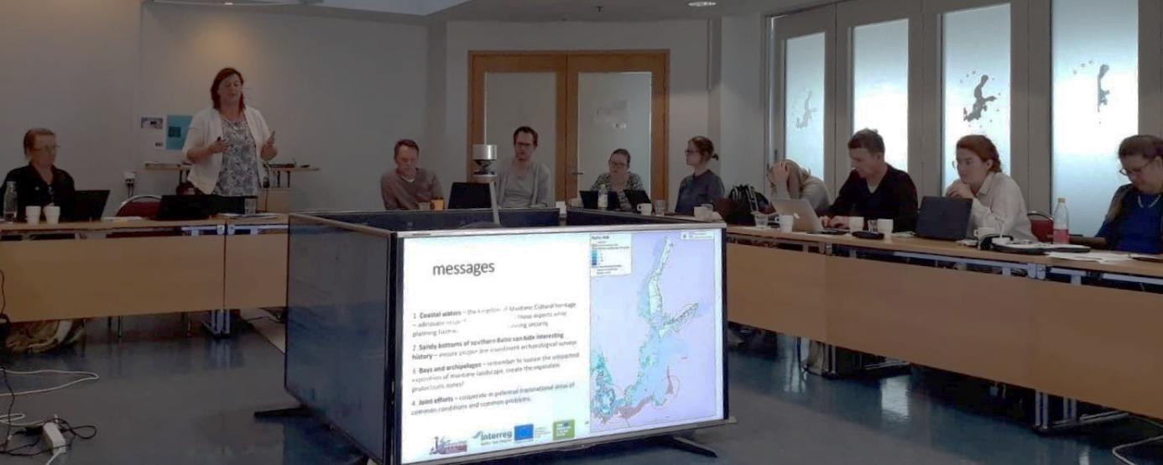

Conclusions

The so far organized stakeholders’ involvement seems to be successful and useful for Maritime cultural heritage managers (project partners). The range of involved stakeholders was wide, including practitioners as well as scientists and administration. The composition of participants depended on the discussed topics and was well targeted by the partners. It seems that the most important group were divers, contributing with new practical knowledge and sometimes new data. One of the reflection from the Finnish stakeholders involvement process was that the national register of UCH objects was substantially verified and enlarged.
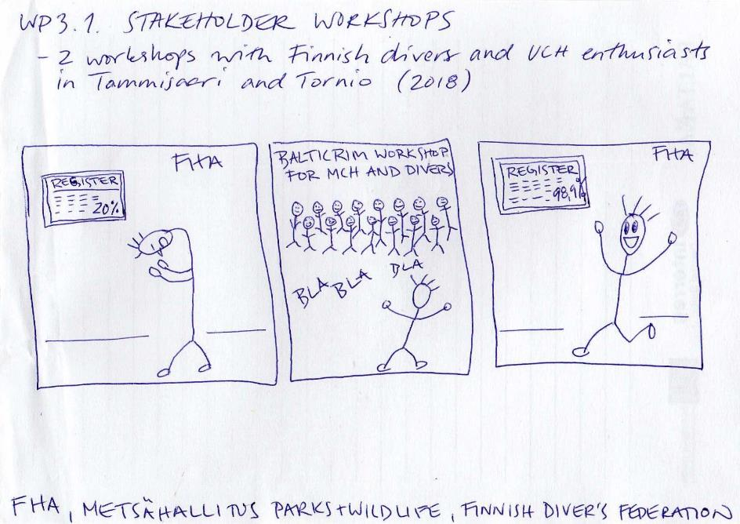
The meetings also contributed to the case studies as verifying the designation of areas, the selection of MCH assets and discussing the planning challenges and solutions. The awareness of the stakeholders about the role of the maritime spatial planning was strengthen.

Good examples
Spot the stakeholder – Russian example
At the beginning, the analyse of Russian stakeholders was conducted to determine who should participate in an cross-sectoral dialogue during the process of MSP, as well as in the development and coordination of MCH management measures. The approach to choose the stakeholders was based on:
- sectors of economic activity that can have a significant negative impact on MCH and requires certain restrictions;
- activities competing for space with priority areas of MCH;
- activities which development is compatible or complementary to MCH, for example, environmental protection, tourism;
- civil society groups and communities interested in maintaining MCH;
- authorities somehow connected with activities in the marine area;
- expert organizations in the field of MCH and MSP;
- planners.
The list of relevant stakeholders with their contacts has been formed, starting from the sectors like fishing, tourism, nature protection, shipping, to the regional and local authorities, research institutions and social organisations associated with the Maritime Cultural Heritage.
The subsequently organised workshops in St. Petersburg were gaining the selected earlier, targeted stakeholders.
Interactive results – Finnish maps
During the stakeholders meetings the results of the discussions have been directly transferred onto maps, using GIS software, which allow to spot the new valuable places using the practical knowledge of divers.
Meet often – German route
Not only the big cross-sectoral workshops are of great value, but also smaller, intensive dialogues with just few, well targeted people are of great importance as allowing to get responses to precisely asked questions and needs.
Use external events – Russian activities
Not only the project meetings but also bigger external events are worth of using as a medium to transfer the information about the project and to raise awareness of the society about the MCH. In Kaliningrad the different public events were used to approach wider public like: the Russian Day of Divers, the Water Assembley (maritime fest) or International Women Diving Day.

Recommendations for further stakeholders involvement
Make use of the BalticRIM WP 2 results
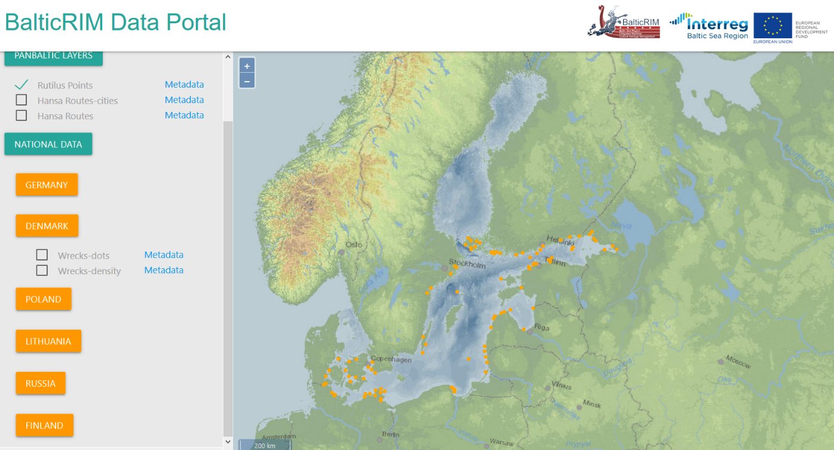
One of the tasks of the project (within GoA 2.3) was to develop a visualization tool transferring the sectoral (cultural heritage) knowledge into spatial language, which can be used by maritime spatial planners – so called BalticRIM Data Portal.
It allows to view data published by national data providers through OGC open geospatial standards – WMS and WFS, that are related not only to underwater cultural heritage but also to coastal and nearby areas with high cultural significance.
The present stage of the online service provides various possibilities for the users. It consist of 2 sections: the first one refers on specific case studies at national level, while the second one is related to Pan-Baltic datasets that exceed the borders of a country and affect more than two, such as the Hansa Routes. So far, most of the data that are available online are displayed only for illustration reasons, do not come from official providers and might miss accuracy or metadata.
The BalticRIM portal should be intensively used in the next workshops organised by the project, especially by the planning cases, in order first to base the discussion on national data, secondly to provide feedback on the performance and usefulness of the portal.

Maritime Heritage Atlas – presents the sectoral maps and descriptions of the cultural potential in the Baltic Sea Region including having spatial references. Check out the proposed zooning options and discuss it with your planning experts. Use it within your case studies discussions.

Zooning proposal for MSP practice:  - Zones carefully researched in which probably key MCH has been already identified and mapped by UCH does not play a leading role.  - Zones carefully researched in which probably key MCH has been already identified and mapped and MCH can activate multi-use of the sea. (MCH has important economic potential).  - Zones, which have not been carefully researched with regard to MCH - but MCH can appear there not intensively.  - Zones which have not been carefully researched with regard to MCH but MCH is expected to appear there (busy ancient trade routes, changes of the coast, battlefields etc.) Here the focus should be on the UCH that is not so intensively represented in the BSR, e.g. paleo-remainings. | 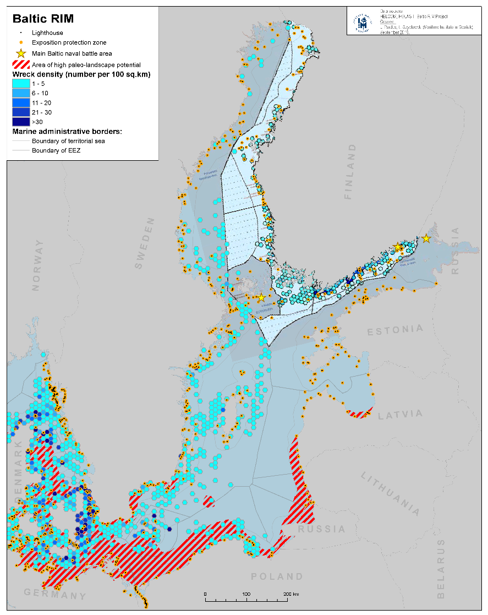

Bibliography

Matczak M., Przedrzymirska J., Zaucha J., Schultz-Zehden, A., Handbook on multi-‐level consultations in MSP, PartiSEApate report S.Pro, Berlin 2014
Matczak M., Zaucha J., Altvater S., Turski J., Witkowska J., The Baltic Maritime Heritage – spatial atlas, BalticRIM report, 2019
Schrøder L., Georgati M., Methodology and obstacles during schematization of Cultural Heritage assets, BalticRIM internal status report WP 2 GoA 2.3, 2019

PartiSEApate project – Multi-level governance in maritime spatial planning throughout the Baltic Sea Region http://www.partiseapate.eu/

Inputs from BalticRIM project partners:
Daniel Zwick - State Archaeology Department of Schleswig-Holstein;
Riikka Tevali – Finnish Heritage Agency
Leyla Bashirova - ABIORAS

Stakeholder Involvement in Long-term Maritime Spatial Planning: Latvian Case, AC Konsultacijas Ltd, BalticLINes report, 2017 https://vasab.org/wp-content/uploads/2018/06/Stakeholder_Involvement_Latvian_Case.pdf
Handbook on multi-level consultations in MSP, PartiSEApate report, 2014
Pan-Baltic stakeholders’ dialogue on MSP: Synthesis report from PartiSEApate single-sector workshops held in 2013, Partiseapate report, 2014, www.partiseapate.eu

